**Ninai Waterfall**

 Ninai is a waterfall in Dediapada taluka of Narmada district in the Indian state of Gujarat. Ninai is located off State Highway 163 (Gujarat). It is approximately 35 km from Dediapada and approximately 143 km from Surat. Nearest railway station is Bharuch which is around 125 km away and nearest airport is Surat. The height of Ninai falls is more than 30 feet. It is in Dediapada’s beautiful forest ranges ranges besides Shoolpaneshwar wildlife sanctuary.

Ninai Falls has tremendous beauty around it. It is situated in [Dediapada](https://en.wikipedia.org/wiki/Dediapada" \o "Dediapada)'s beautiful forest ranges besides [Shoolpaneshwar wildlife sanctuary](https://en.wikipedia.org/wiki/Shoolpaneshwar_wildlife_sanctuary" \o "Shoolpaneshwar wildlife sanctuary). The [Narmada district](https://en.wikipedia.org/wiki/Narmada_district) collectorate is promoting the [Sardar Sarovar](https://en.wikipedia.org/wiki/Sardar_Sarovar) dam and its surrounding tribal region as possible eco-tourism hotspots. The plan includes the Ninaighat waterfalls also.

1st image:

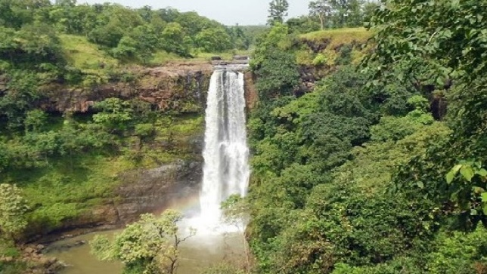

<https://cdn.s3waas.gov.in/s396ea64f3a1aa2fd00c72faacf0cb8ac9/uploads/bfi_thumb/2018073093-olwaofl9t4vh966jx3a98e5libmfl8c3fjycs59hmy.jpg>

2nd image:

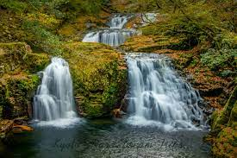

<https://encrypted-tbn0.gstatic.com/images?q=tbn:ANd9GcRjANVJ95IF39ic2IqspHvXifTy6YSO8hfKFUn5cOxYIp3WZYYPiwatflWIkQ5TbvWQKuM&usqp=CAU>